LinkedIn 101: Using LinkedIn to Land Your Dream Job Before You Graduate

LinkedIn is helping soon-to-be grads from around the country tap into their professional community—whether they realize they have one already or not.

Trying to land your dream career out of the gate is a tall order. But here’s the good news: There are roughly 11 million job openings per month in America at any given time. Sure, you don’t want all those jobs, but you want some of them—and some of them want you!

LinkedIn connects qualified candidates with companies and organizations that crave top talent. With these tips, you’ll be well on your way to snagging a seat at the professional table before graduation.

Why LinkedIn?

- 80% of LinkedIn members consider professional networking to be important to new job opportunities and career success, according to LinkedIn research.
- 70% of people were hired at a company where they had a connection
- More than 20 million professionals including recruiters, hiring managers and decision makers use LinkedIn every week

With 530+ million professionals in the LinkedIn community, there is no other place where you can access such a wide range of knowledge, skills and resources to help you reach your goals.

Entrepreneur? Create your own job — become a freelancer

- Nearly 20% of freelancers confirmed they'll make six figures or more this year with their freelance work, according to LinkedIn
- More than half of freelancers confirmed that they will never return to more traditional, full-time employment
- 80% of freelancers do not actually have any concern about their freelance work being replaced by technology, artificial intelligence, or automation in the next 10-20 years.
LinkedIn ProFinder started as an idea that has grown into a vibrant marketplace being used by more than 70,000 freelance professionals across the nation. LinkedIn has seen client demand surge with weekly requests for proposals growing more than fivefold in one year.

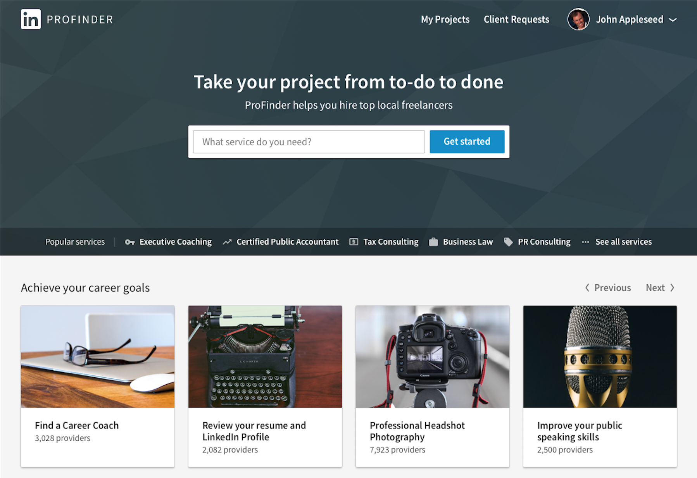

Seek career advice from others
- More than 80% of professionals on LinkedIn have stated they either want to have a mentor or be one to others
- More than half don’t know where to begin and more than one-third have a hard time finding the right person
LinkedIn launched Career Advice, a new feature that helps connect members across the LinkedIn network with one another for lightweight mentorship opportunities. Whether you need advice on your career path, switching to a new industry or best practices for a project you’re working on, Career Advice can help you find and connect with the right person who can help.
Learn the skills needed for your next gig
- One-third of job-seekers have expressed concern that they don’t have the necessary skills to be competitive in the job market
- Many people who are looking for work from home jobs use LinkedIn learning to gain the skills needed to be an ideal candidate for remote work.
With LinkedIn Learning, you can now access a gigantic database of online courses on topics from coding and graphic design to public speaking. And here’s the best part: each course is typically sliced up into very manageable 5-10 minute learning chunks. Learning a new skill over the course of a week quickly becomes very achievable.
What now? — Get started

Create or update your LinkedIn profile today. This provides other LinkedIn members with a better understanding of the unique skills, interests, and experience that make you — you.

- Make sure you have a profile photo - it will help get you recognized and connect to potential opportunities. Members with a profile photo receive up to 21x more profile views and 9x more connection requests.

- Members with current positions are discovered up to 16x more in recruiter searches

- Members with more than 5 skills are 27x more likely to be discovered in searches by recruiters

- Including the city where you are based makes you stand out up to 23x in searches
Bonus: Check out Resume Assistant, a new integration from Microsoft and LinkedIn that acts as a resume generator and helps you craft a compelling document directly within Microsoft Word.

